**Assignment 2**

**Scope of our project:**

* Mentorship:Mentorship involves a dynamic and collaborative relationship between a more experienced individual (mentor) and a less experienced individual (mentee). The scope of mentorship extends beyond traditional education and encompasses various fields, including career development, personal growth, and skill enhancement. It aims to provide guidance, support, and knowledge transfer to facilitate the mentee's professional and personal development. Mentorship fosters a positive learning environment, promotes networking, and helps navigate challenges, ultimately contributing to the mentee's success.
* Strong Student community:A strong student community fosters collaboration, knowledge-sharing, and personal growth. It provides a platform for academic and extracurricular engagement, enhancing the overall learning experience. This community often extends beyond classrooms, encompassing diverse interests, fostering leadership skills, and creating a supportive network for future endeavors. It plays a pivotal role in shaping well-rounded individuals by promoting teamwork, cultural exchange, and a sense of belonging, contributing significantly to the holistic development of students.
* Scholarship programs:Scholarship programs have a broad scope, facilitating access to education, recognizing merit, promoting skill development, fostering diversity, supporting research, impacting communities, developing leaders, and contributing to societal progress. They play a crucial role in breaking financial barriers and creating a positive ripple effect on individuals and societies.
* Gamified learning for a healthy competition: Gamified learning with a focus on healthy competition involves integrating game elements into educational activities to engage and motivate learners. The scope includes designing interactive challenges, quizzes, or simulations that encourage participants to compete in a supportive and constructive manner. Features like leaderboards, badges, and rewards can be incorporated to foster a sense of achievement and progression, making the learning experience more enjoyable. Additionally, the scope encompasses creating a platform that allows learners to track their progress, compare scores, and collaborate, promoting a positive and competitive learning environment.
* Career counseling:Career counseling involves guiding individuals in making informed decisions about their career paths. This process typically includes assessing one's interests, skills, values, and personality traits. A career counselor may use aptitude tests, personality assessments, and discussions to help clients explore various occupations and industries. The scope of career counseling extends to providing information about educational and training requirements, job market trends, and potential career paths. Additionally, career counselors may assist with resume building, interview skills, and job search strategies, fostering a holistic approach to career development.

**Challenges faced and Overcoming Adversities:**

Finding a suitable and unbiased dataset that accurately represents the target population was challenging, especially for underprivileged students. model unintentionally perpetuated biases present in the training data, leading to unfair predictions. Ensured that our dataset is diverse, inclusive, and representative of the population we aim to support.

**Value Creation provided:**

Our work contributes to creating a comprehensive AI-powered solution that not only predicts students' performance but also empowers educators and support systems to intervene early and provide targeted assistance. This aligns well with the goal of preventing academic difficulties and supporting underprivileged students to improve their educational outcomes. The predictive nature of our model enables early identification of students who may be at risk of facing academic difficulties. This early intervention can be a key factor in preventing dropouts and providing timely support to those who need it the most.

**Glimpse of our project:**

The first aspect is identifying the week student and the main reasons why they are facing this difficulty. Hence we have made a model for this problem which identifies whether the student will pass or fail and main reason for their failures

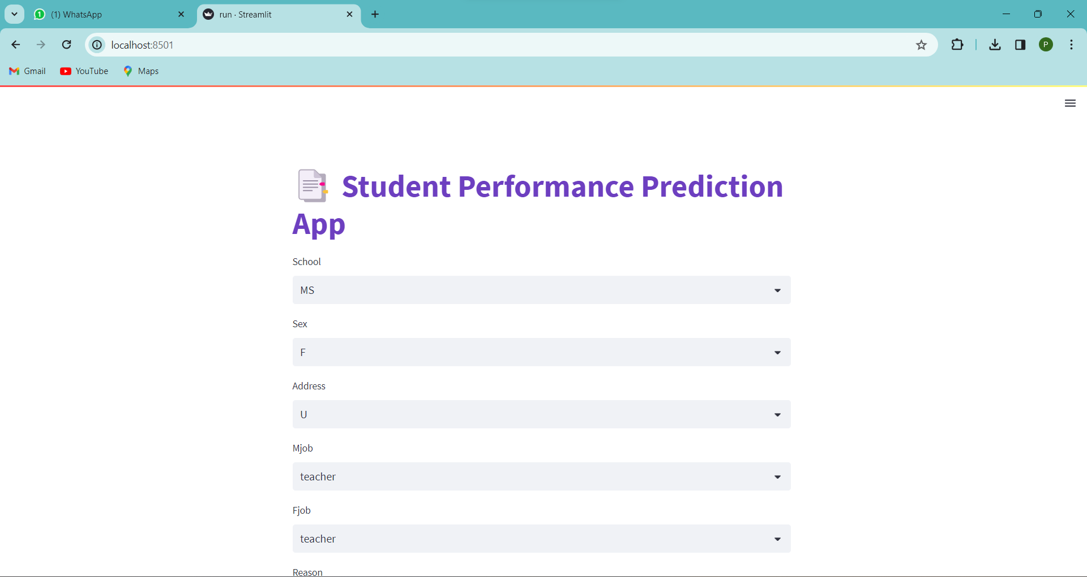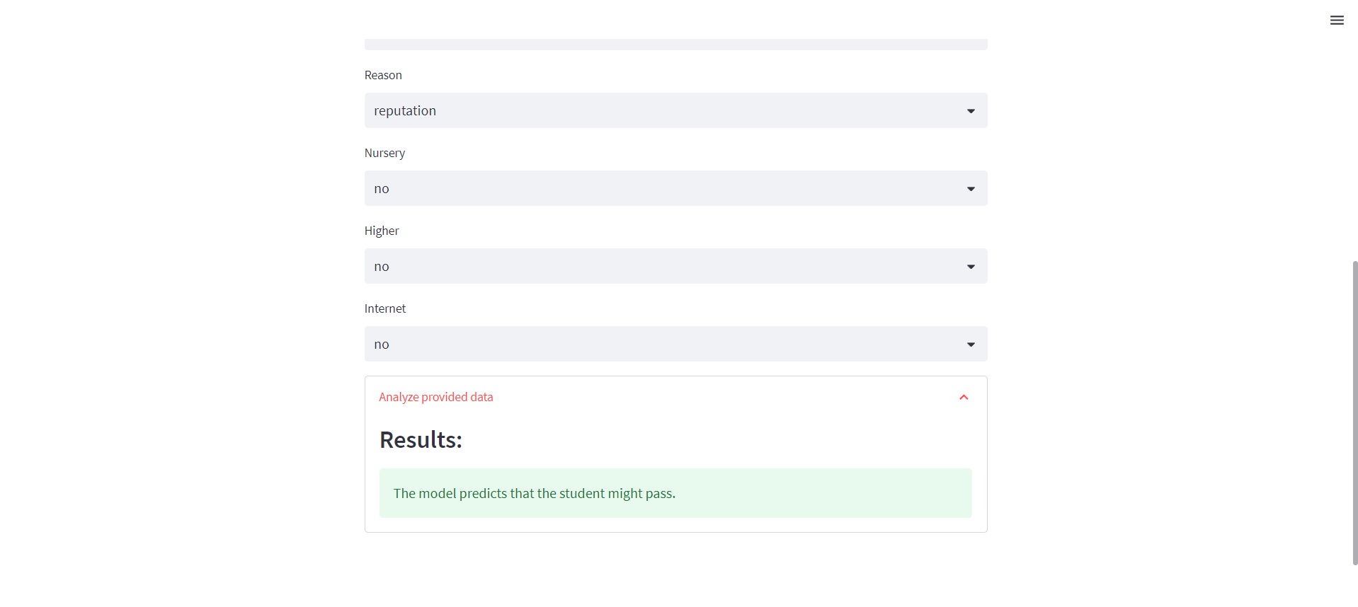

After this we made a website which provides free course and offers roadmap to the students who are under privileged.

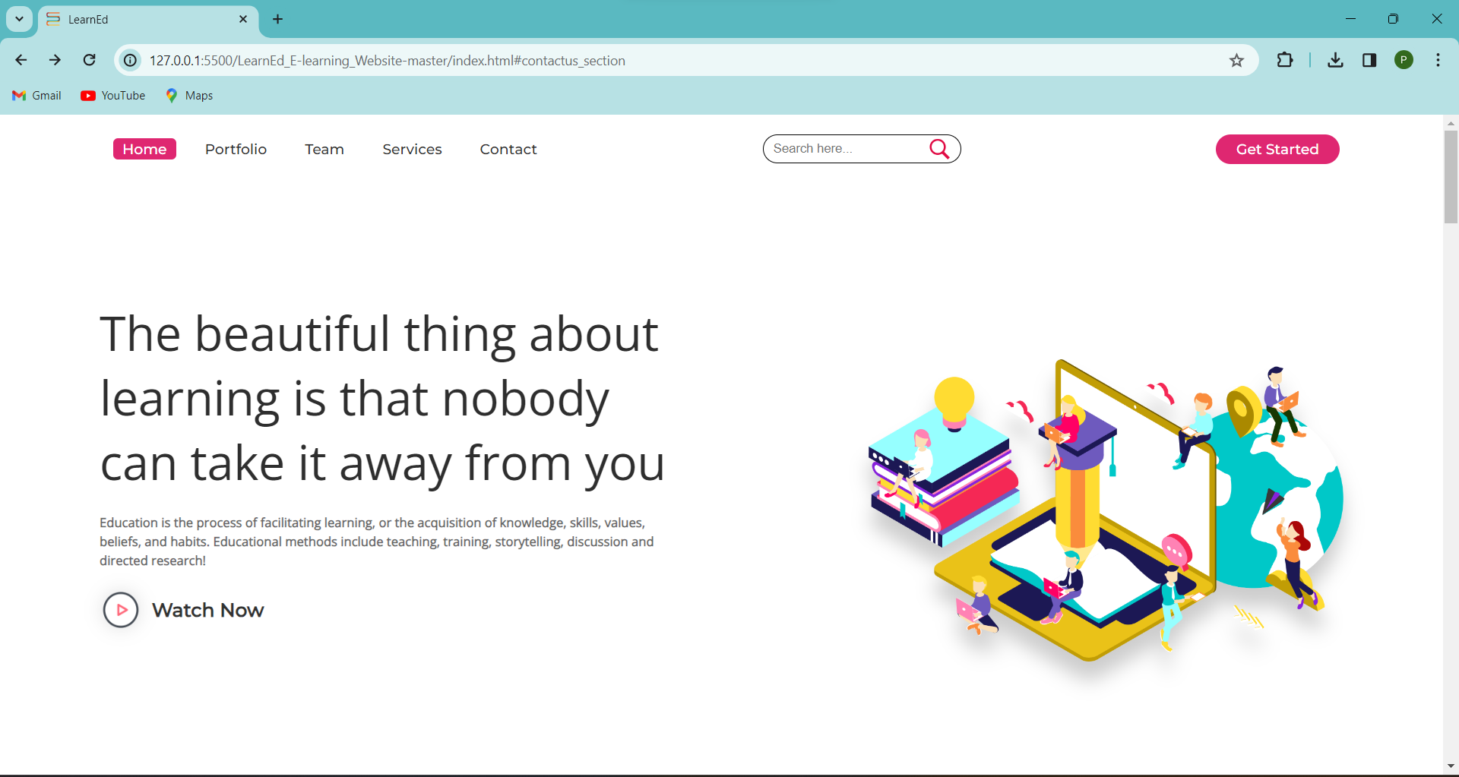  
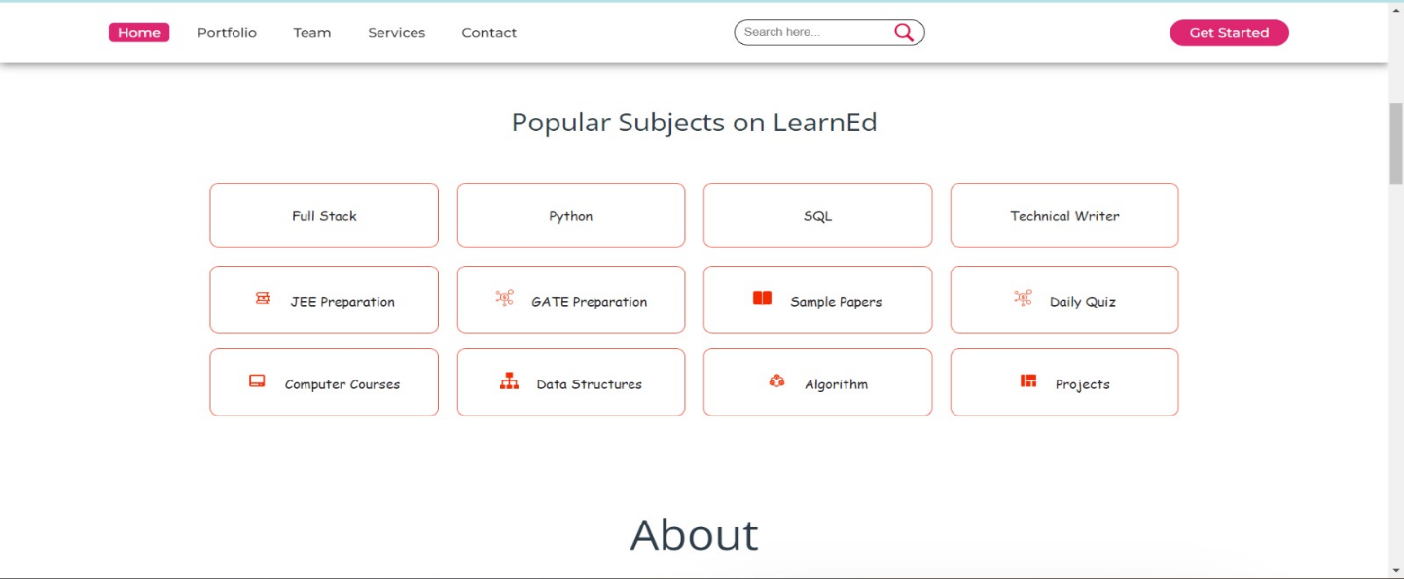  
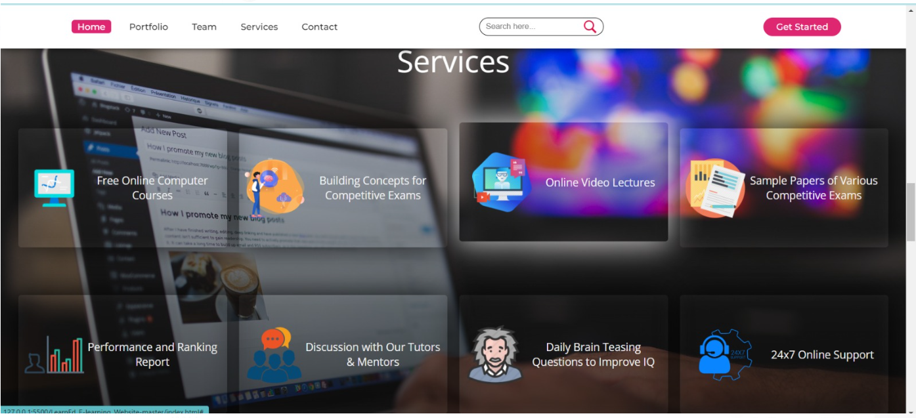

This is the glimpse of the website and now we will give you the glimpse of roadmap and courses

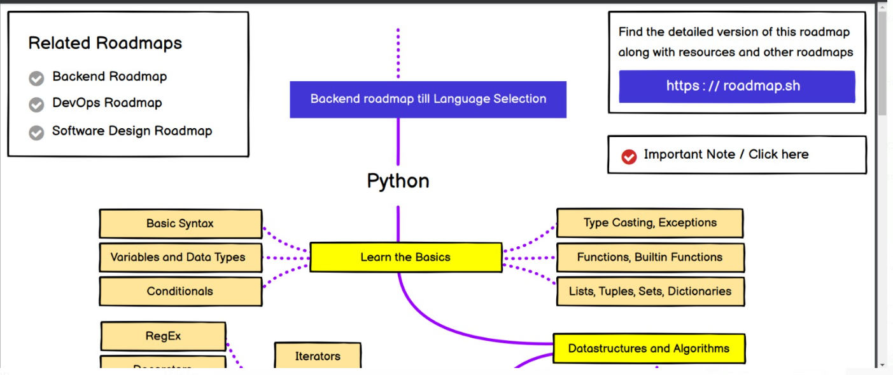  
  
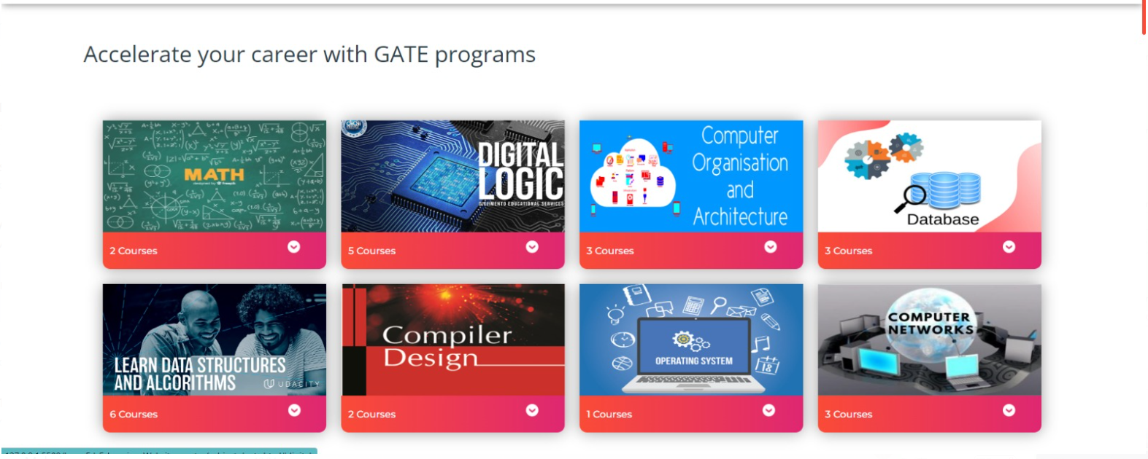  
  
  
Video Link: <https://drive.google.com/drive/folders/1bh9jou_38SYsQ5Qquuaf7bXeqIlOEQBj>

The video does not contain audio but we have provided the description here in this doc.